ABP Portfolio Screen Shots

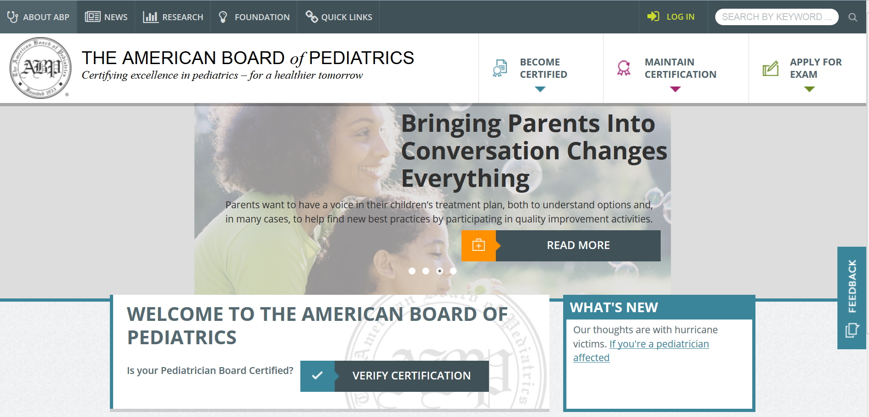

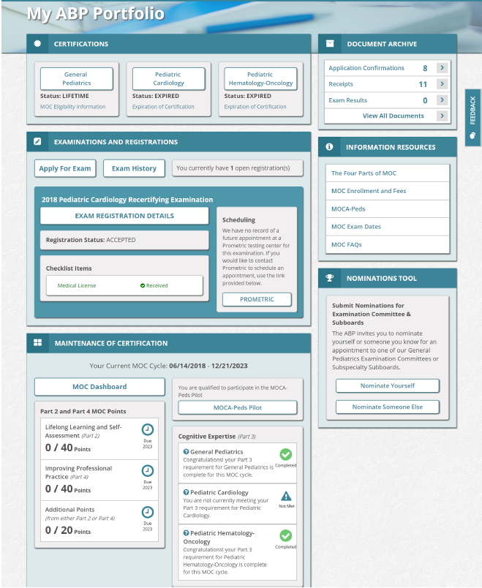

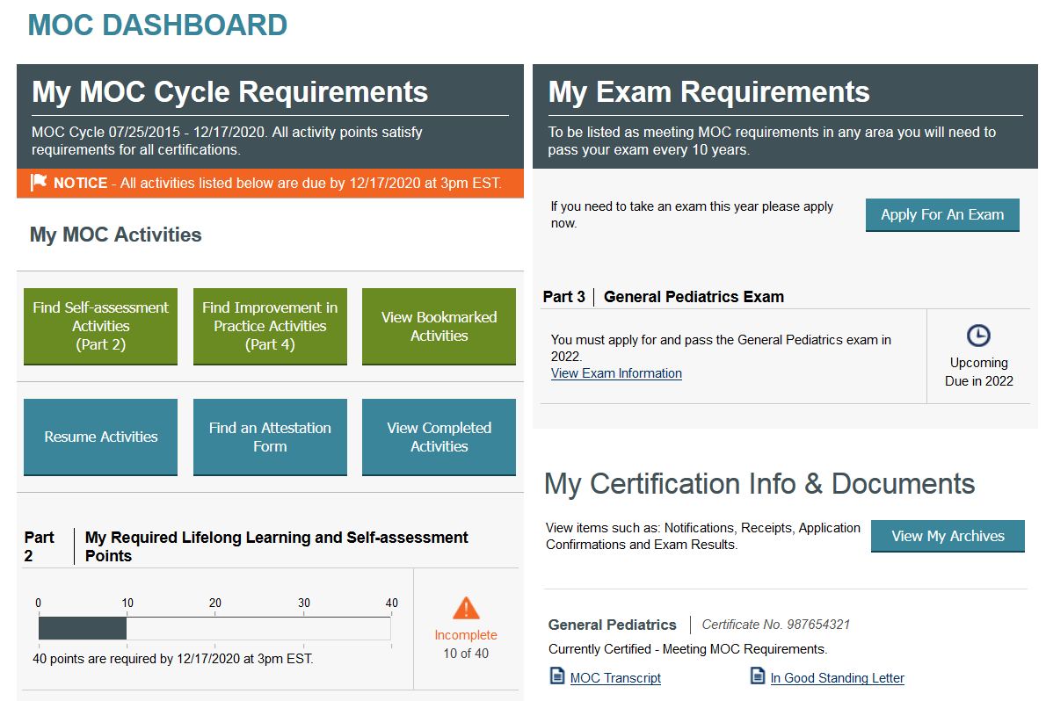

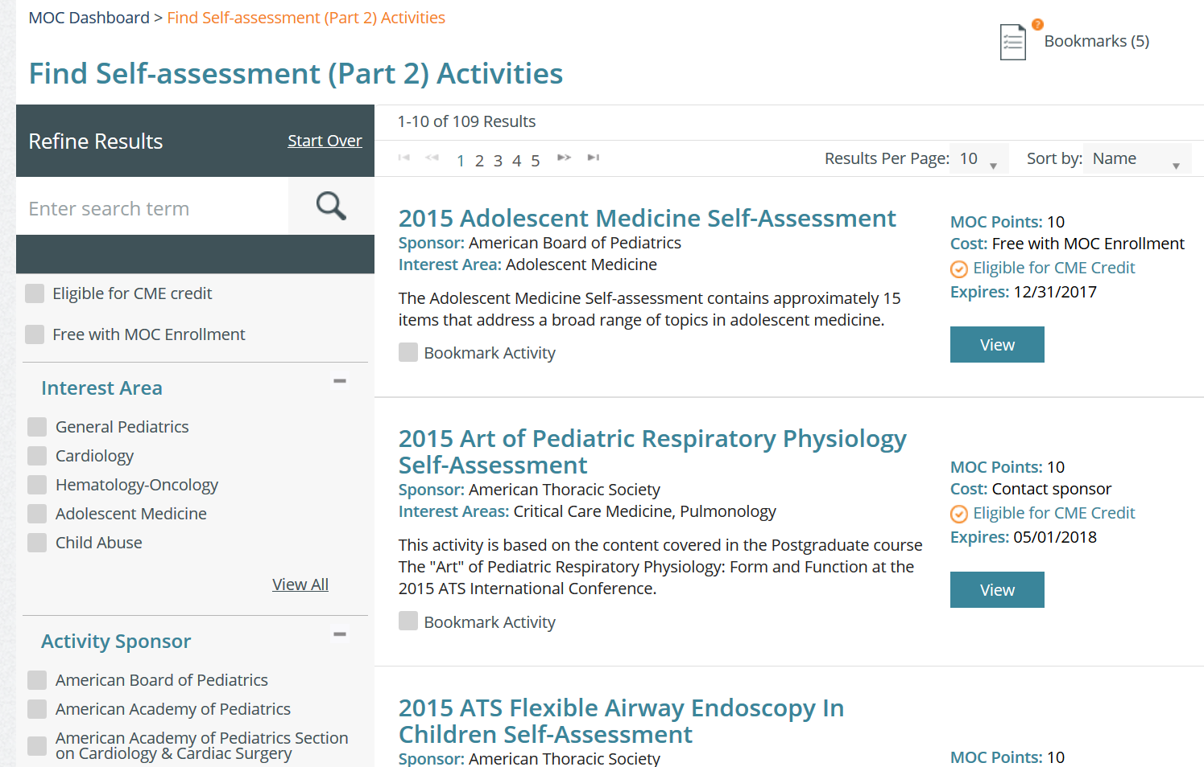

**Type “Assessment, Evaluation and Treatment of the Transgender Child” in the Refine Results search box**

**Check “American Board of Pediatrics” in the Activity Sponsor section**

