Instructions for Accessing ABP Activities

- Log into your ABP portfolio and click on My MOC Dashboard.

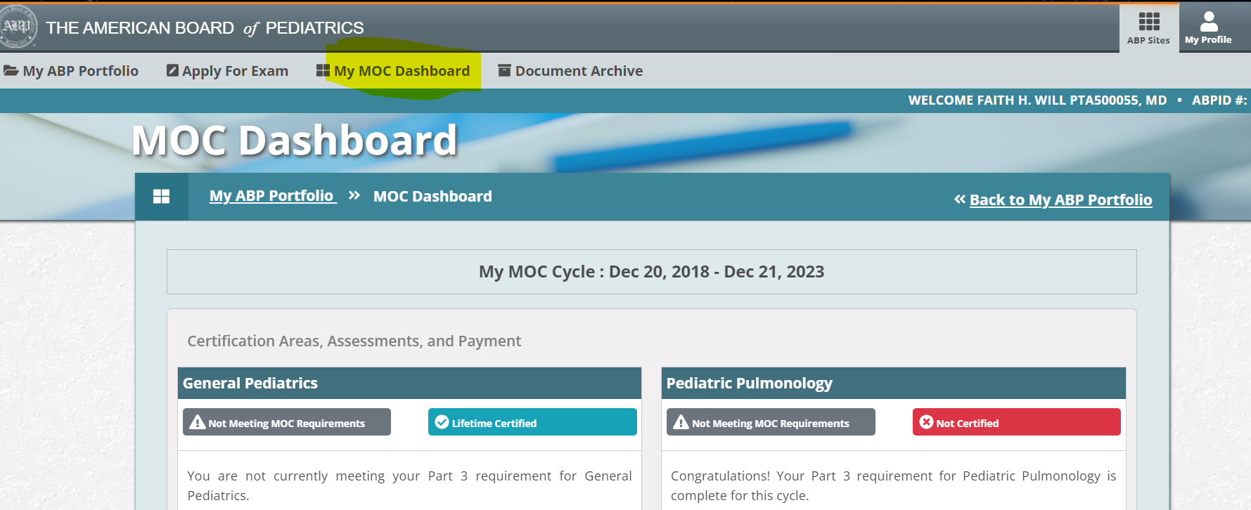

- Scroll down until you see Quality Improvement, Self-Assessment and Licensure and click on Part 2 as shown below.

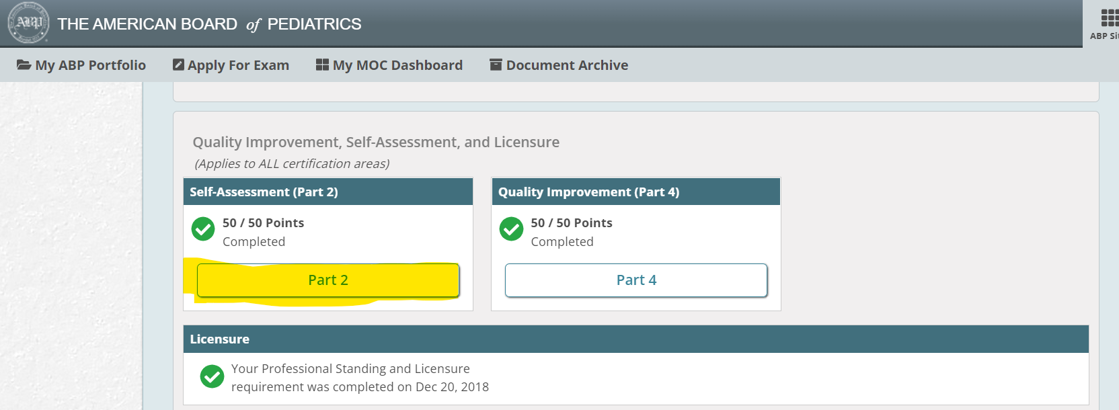

3. Click on Self-Assessment (Part 2) Search.
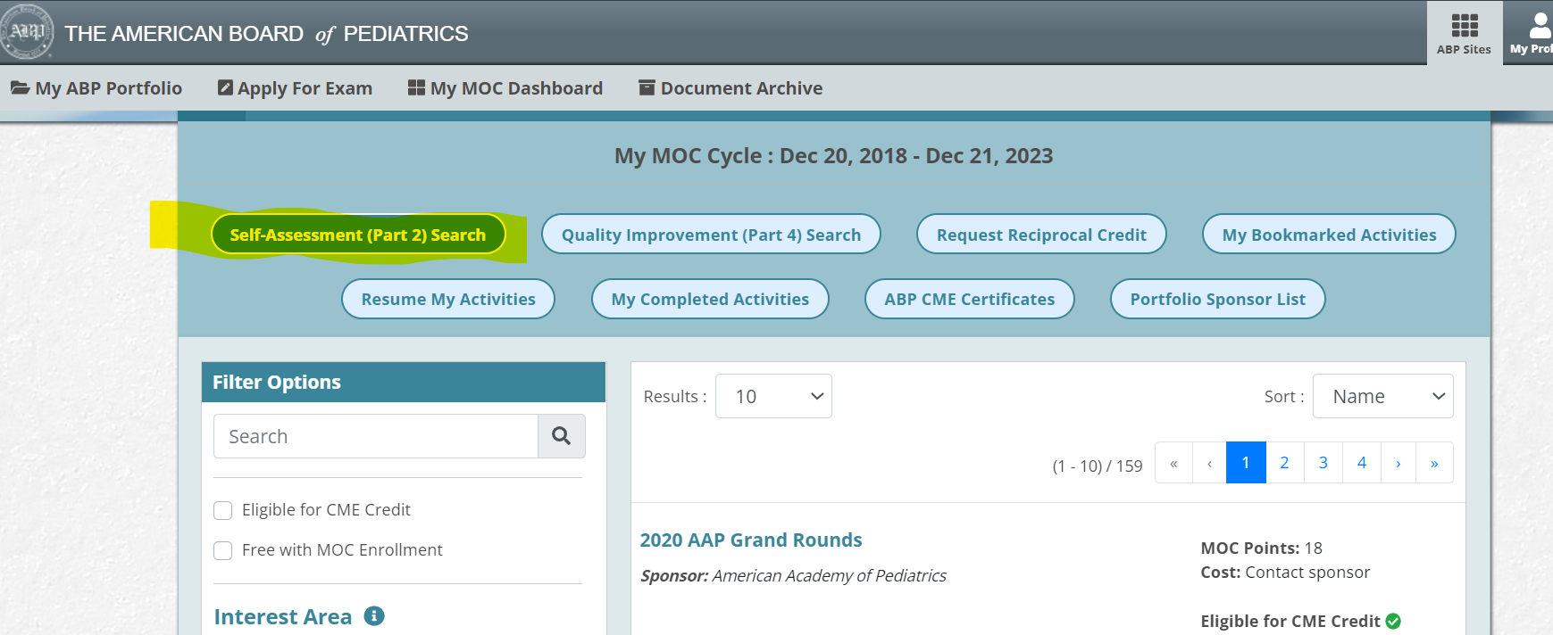

4. In the search bar, type either, “Impacts of Climate Change on Pediatric Health Care OR Emotional Health and Resilience for Patients and Families with Chronic Pediatric Conditions” and click on the magnifying glass. click View as shown below.

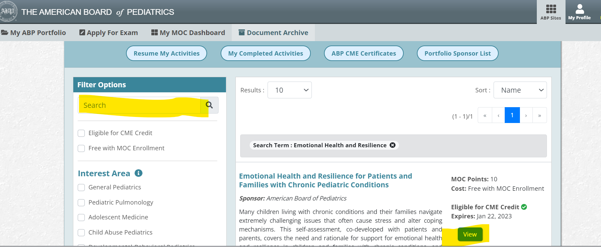

- Click Launch Activity as shown below.
