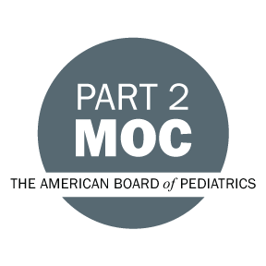
Michigan Chapter American Academy of Pediatrics (MIAAP)
Maintenance of Certification (MOC) Part 2

Michigan Chapter American Academy of Pediatrics is pleased to offer the MOC Part 2 sessions, at MIAAP’s 72nd Annual Conference on Thursday, September 29 at the Sheraton Hotel in Ann Arbor, MI.

Prep and ABP Log-In begins at 12:00 p.m. and the session begins promptly at 12:30 p.m. and is expected to be completed by 3:30 p.m.

To ensure that you will not encounter any problems during the session, please take a moment prior to the meeting to complete the following steps to register for the ABP Self-Assessment:

- Please bring your ABP Portfolio username and password; if you do not have one, please establish this credential BEFORE the meeting. Only ABP diplomats will be eligible to participate and receive credit for this activity.

- You must be in good standing with the ABP to participate in this activity. BEFORE the meeting; log on to your ABP Portfolio and verify that you have made the necessary payments toward your MOC credit requirement. ABP Portfolio Log-In

- Bring a laptop or tablet. We recommend you login to the assessment on the device you will be using a few days in advance to ensure you will have access. Please be certain your browser is the most current version of Chrome (Download Chrome) or Firefox (Download Foxfire).

- You must review resources prior to the session to become familiar with the materials.

- All resources will also be emailed in advance by Emily Rambo at emily.rambo@miaap.org and can be found on the MIAAP website here: www.miaap.org/moc-2.

We will help resolve as many issues as possible prior to the session in an effort to provide a seamless learning experience. If you have any problems or questions prior to the session, please call Emily Rambo at (517) 484-3013.

We look forward to seeing you at MIAAP's Annual Conference.

